


ADVANCED SPREADSHEET APPLICATIONS
(235)

NATIONAL 2020

Production:

Printout 1 (43 points)
Printout 2 (65 points)
Printout 3 (65 points) Printout 4 (77 points)
Printout 5 (15 points)
Printout 6 (65 points)
Printout 7 (40 points)
TOTAL POINTS (370 points)

Judge/Graders: Please double check and
verify all scores and answer keys!

Property of Business Professionals of America.
May be reproduced only for use in the Business Professionals of America
Workplace Skills Assessment Program competition.

General Instructions

- Key your contestant number in the right section of a footer on each printout on a separate line in the footer. Your name or initials should not appear on any work you submit.

- Center the following information in a header on each printout: The sheet name.
- If you finish before the end of the testing time, notify the proctor. Time may be a factor in determining the winner in the event of a tie.

- When turning in your contest, arrange all jobs in the correct printout order (included in instructions).

- Write your contestant number in the provided spaces on the test cover page.
Grading Rubric

Printout 1 | Points | Points Earned | Total Points
Sheet Name (Summary) in the center section of header | 5
Inserted Contestant Number and Printout 1 in right section of footer | 5
Format Columns B3-G8 in currency with 2 decimals | 5
Bold row 1 | 5
Format B1 to G1 with fill style 40% accent 6. | 5
Fill rows 4, 6, and 8 with custom color:  - Red 217  - Green 225  - Blue 242 | 3
Format B1 to G1 with a think bottom border | 5
Place left/right border for columns B through G | 5
Delete Row 2 | 5
Totals for Printout 1 | 43
Printout 2 | Points | Points Earned | Total Points
Sheet Name (Summary) in the center section of header | 5
Inserted Contestant Number in right section of footer | 5
On the Summary Sheet use a 3-D reference to total the sales in cells B3:B8 for both sales periods. | 10
On the Summary Sheet use a 3-D reference to total the consultant fees in cells C3:C8 for both sales periods. | 10
On the Summary Sheet use a 3-D reference to total the federal tax in cells C3:C8 for both sales periods | 10
On the Summary Sheet use a 3-D reference to total the state tax in cells C3:C8 for both sales periods. | 10
On the Summary Sheet total the expenses. | 5
On the Summary Sheet compute the profit for each company. | 5
Best Fit all the columns | 5
Totals for Printout 2 | 65

Printout 3 – Formulas (Period 1 Sales) | Points | Points Earned | Total Points
Inserted Contestant Number in right section of footer | 5
H3 a function that totals the 6 month sales for the company. Filled down. | 10
I3 an absolute formula that calculates the consultant fee for each company pays. Fill Down. | 10
I3 an absolute formula that calculates the consultant fee for each company pays. Fill Down. | 10
J3 an absolute formula that calculates the federal tax each company pays. Fill down. | 10
K3 an absolute formula that calculates the state tax each company pays. Fill down. | 10
Print out the page, landscape orientation, centered vertically and horizontally. Your report should fit on one page with no truncated data. | 10
Total Printout 3 | 65
Printout 4 | Points | Points Earned | Total Points
Sheet Name (Period 1 Sales) in the right section of header | 5
Inserted Contestant Number in right section of footer | 5
Format columns B3-K8 in currency with 2 decimals | 10
Insert the following text:  - H1: 6 Month Sales  - I1: Consultant Fee  - J1: Federal Tax  - K1: State Tax  - I2: 10  - J2: 17  - K2: 11 | 7
Format I2 to K2 to percentages with zero decimals | 5
Duplicate spreadsheet and rename: Period 2 sales | 5
Typos on Printout 1 (0 errors 30 points, 1 error 25 points, 2 errors 20, 3 errors 10 points, 4 or more errors 0 points) | 30
Printout in landscape orientation, centered vertically and horizontally. Your report should fit on one page with no truncated data. | 10
Total Printout 4 | 77
Printout 5 | Points | Points Earned | Total Points
Sheet Name (Period 2 Sales) in the center section of header | 5
Inserted Contestant Number in right section of footer | 5
A copy of period 1 sales worksheet | 5
Total for Printout 5 | 15

Printout 6 | Points | Points Earned | Total Points
Sheet Name (PivotInfo) in the center section of header | 5
Inserted Contestant Number in right section of footer | 5
Create a PivotTable and Chat on a new worksheet using data from the summary worksheet. | 20
Name the worksheet: Pivot information | 5
Use the fields:  - Customer in columns  - Sum of Profit in Values | 10
Fill Chart in cells B7 to G26. | 5
Format the PivotTable data to Currency with 2 decimal places. | 5
Print the Pivot Chart worksheet landscape orientation centered vertically and horizontally on one page. (all or nothing) | 10
Totals for Printout 6 | 65
Printout 7 | Points | Points Earned | Total Points
Macro Named CompanyInfo | 10
Applied keyboard shortcut of CTRL + Shift + Q | 10
Data matches key | 10
Print a copy of the visual basic of the data macro. | 10
Totals for Printout 7 | 40

Printout 1

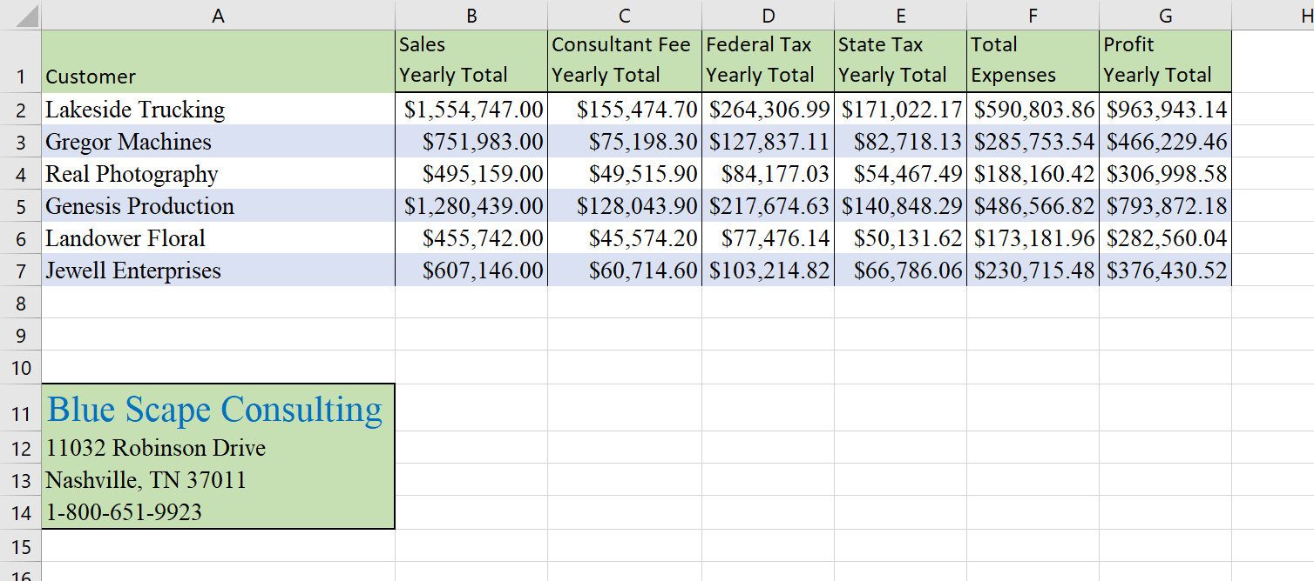

Printout 2

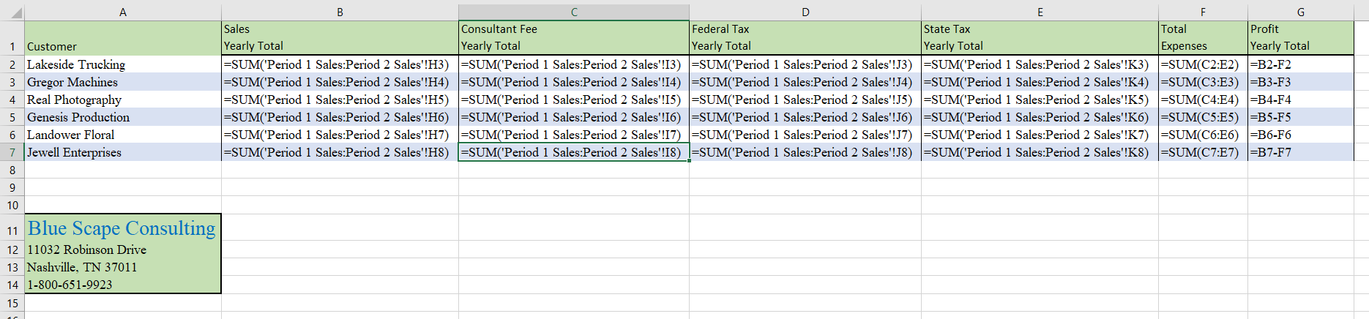

Printout 3
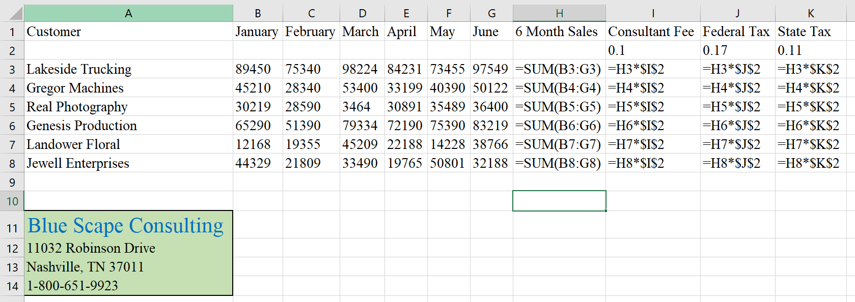

Printout 4
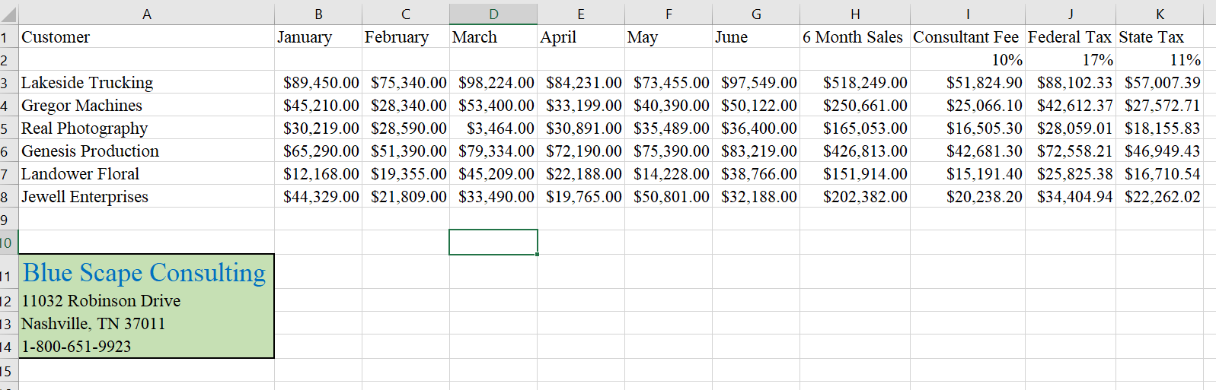

Printout 5
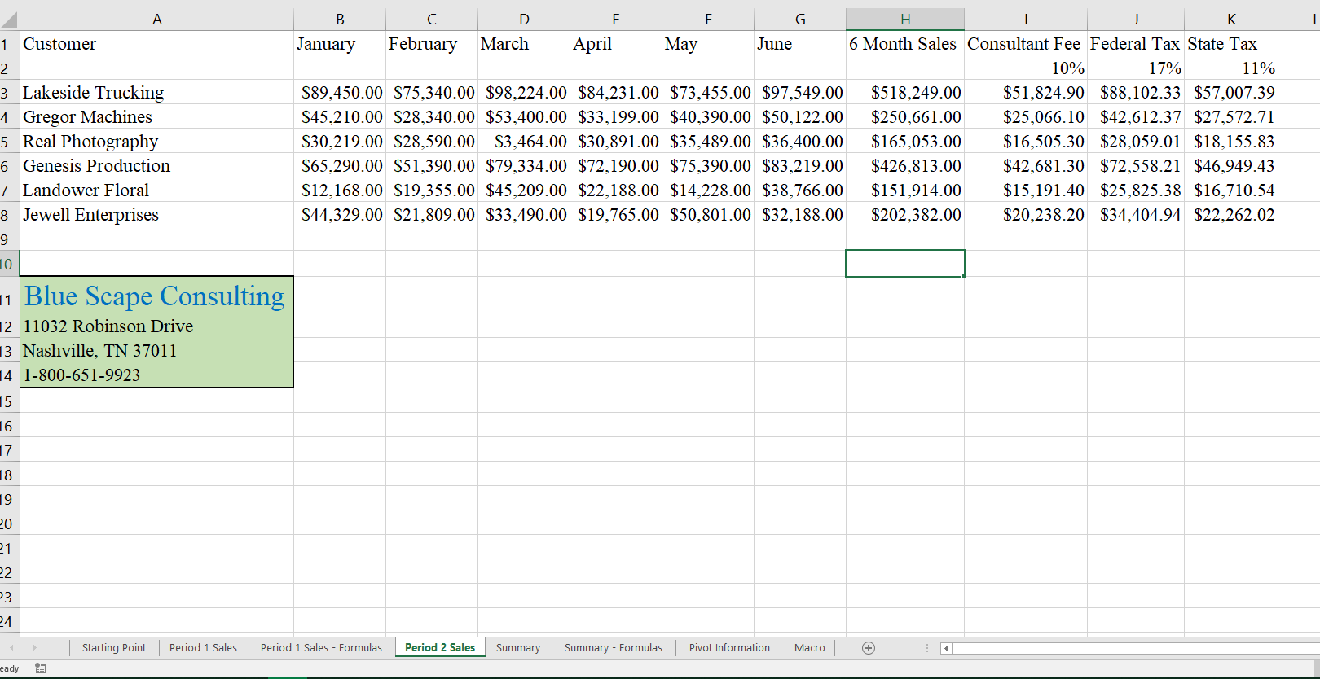

Printout 6
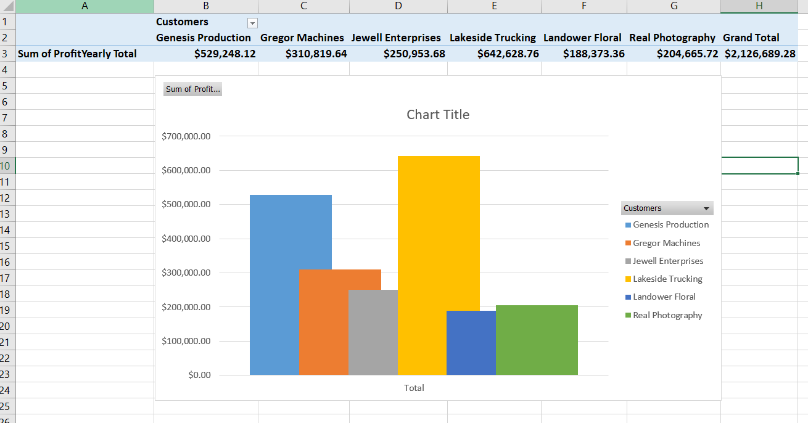

Printout 7

